Given the root of a binary tree, return *the same tree where every subtree (of the given tree) not containing a*1*has been removed*.

A subtree of a node node is node plus every node that is a descendant of node.

**Example 1:**

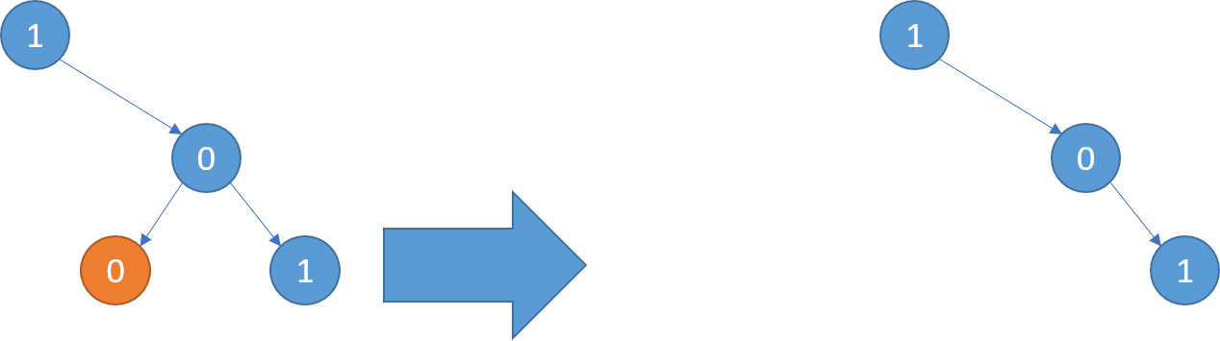

**Input:** root = [1,null,0,0,1]

**Output:** [1,null,0,null,1]

**Explanation:**

Only the red nodes satisfy the property "every subtree not containing a 1".

The diagram on the right represents the answer.

**Example 2:**

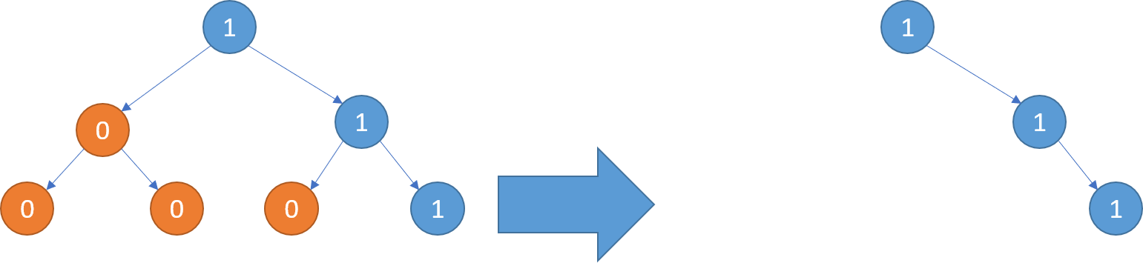

**Input:** root = [1,0,1,0,0,0,1]

**Output:** [1,null,1,null,1]

**Example 3:**

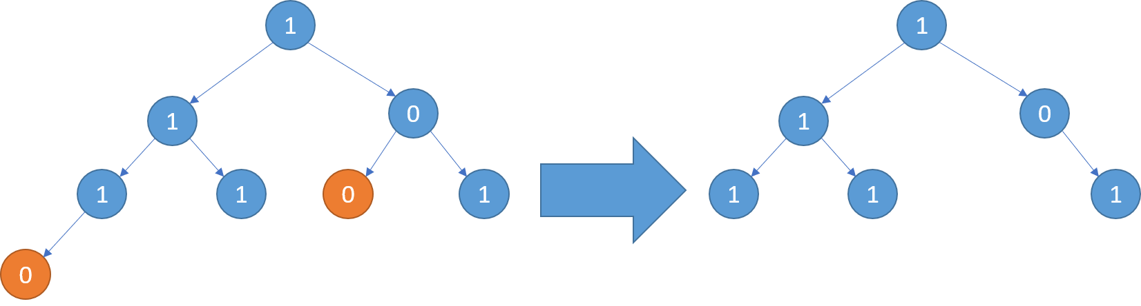

**Input:** root = [1,1,0,1,1,0,1,0]

**Output:** [1,1,0,1,1,null,1]

**Constraints:**

* The number of nodes in the tree is in the range [1, 200].
* Node.val is either 0 or 1.